RESOLUTION NO.__________

RE: CERTIFICATE OF APPROPRIATENESS UNDER THE
PROVISIONS OF THE ACT OF THE PENNSYLVANIA
LEGISLATURE 1961, JUNE 13, P.L. 282 (53
SECTION 8004) AND BETHLEHEM ORDINANCE NO.
3952 AS AMENDED.

WHEREAS, it is proposed to replace the front door with ADA code compliant entry, install new windows, storefront frames on the rear wall and a skylite at 453 Main St.

NOW, THEREFORE, BE IT RESOLVED by the Council of the City of Bethlehem that a Certificate of Appropriateness is hereby granted for the proposal.

Sponsored by: (s)

(s)

ADOPTED BY COUNCIL THIS DAY OF

(s)
President of Council

ATTEST:

(s)
City Clerk

HISTORICAL & ARCHITECTURAL REVIEW BOARD

The applicant is proposing to replace the front door with ADA code compliant entry, install new windows, storefront frames on the rear wall and a skylite at 453 Main St.
APPLICATION #2:

Wens, Inc.
451 Homestead Drive
Nazareth, PA 18064

OWNER:

__________________________________________________________________________

The Board upon motion by Phil Roeder and seconded by Marsha Fritz adopted the proposal that City Council issue a Certificate of Appropriateness for the following:

- Glass transom will have the address applied in vinyl letter with Serifs.

- Frames to be dark bronze in color.

- Re-open three closed openings in the rear of the building and install new Marvin
aluminum clad double hung window.

- Two large openings glazed with aluminum and glass storefront (dark bronze) frames with a door leading to the fire escape.

- Brick walls to be painted Benjamin Moore “Barren Plain” #2111-60 and steel lintels if chosen to be Benjamin Moore “Baby Seal Black” #2119-30.

6. The motion was unanimously approved.
__________________________________________________________________________

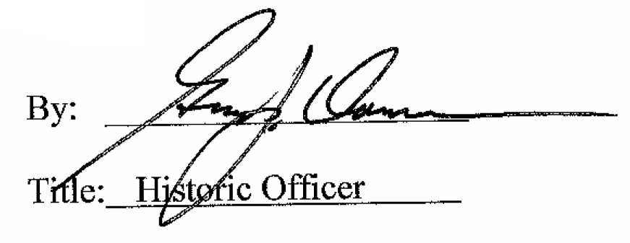

Date of Meeting: January 4, 2017

